MCC SkillUP employment follow-up and adding employment data in MoJOBS
When conducting employment follow-up conversations or calls with SkillUP completers, ask the following questions and complete the form below:
SkillUP Completer name:_________________________________________________
- After completing your MCC SkillUP program did you obtain employment?
No-Never employed after program-Unemployed?-stop
Yes-Employed after program, even for a short time?-continue below:
- Employer_____________________________
- Employer Contact Name___________________________
- Employer Phone number______________________________
- Job Title_________________________________
- Occupation-(In MoJOBs navigator will click “Select Occupation” to add)__________________________
- Green Job? Yes or No
- Hours worked weekly__________________
- Hourly wage______________
- Job Start Date________________
- Job End Date_______________ or Currently Employed (circle)
- Reason for Leaving, if not employed________________________
- Primary Employer Yes or No
- Benefits Yes or No
- Job covered by Unemployment Compensation Yes or No
- Enterpreneurial or Self-Employment Yes or No
- Registered Apprenticeship Yes or No
- Active Military Service Yes or No
- Non-Traditional Employment Yes or No

Give above form to navigator or to SkillUP Manager to enter data into the MoJOBs system.
See page 2 for how to enter data into the MoJOBs system.

MCC SkillUP Staff- How To Enter Employment in MoJOBS:
Click programs and find the completed SNAP app. Click the +.
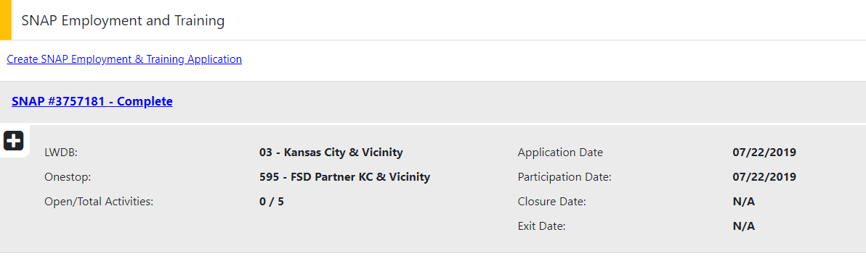

Scroll down and click “Add Employment”
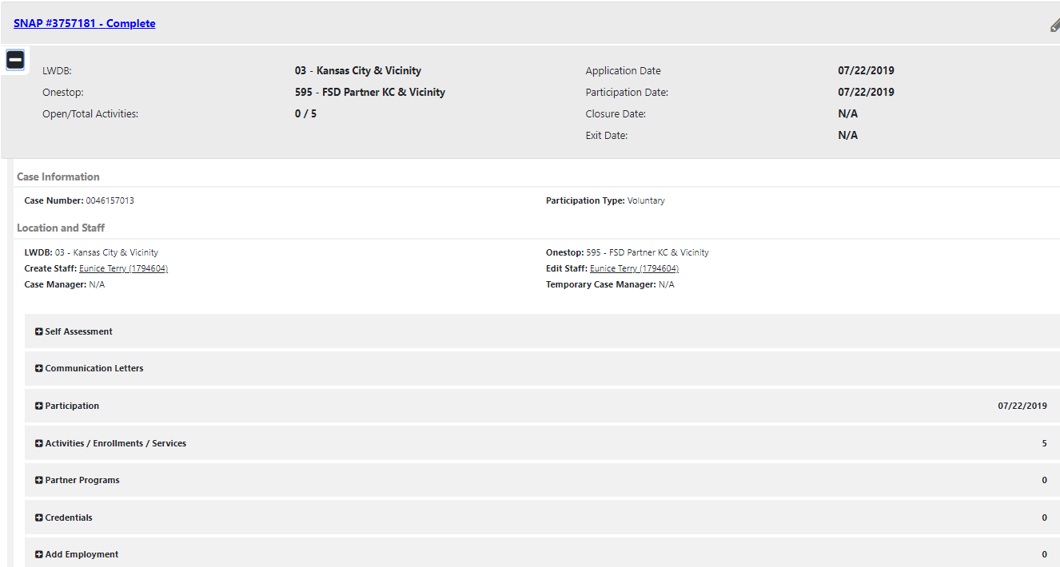

Click “Add Employment”
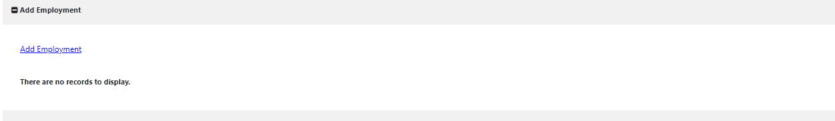

Enter information into required fields marked with *.
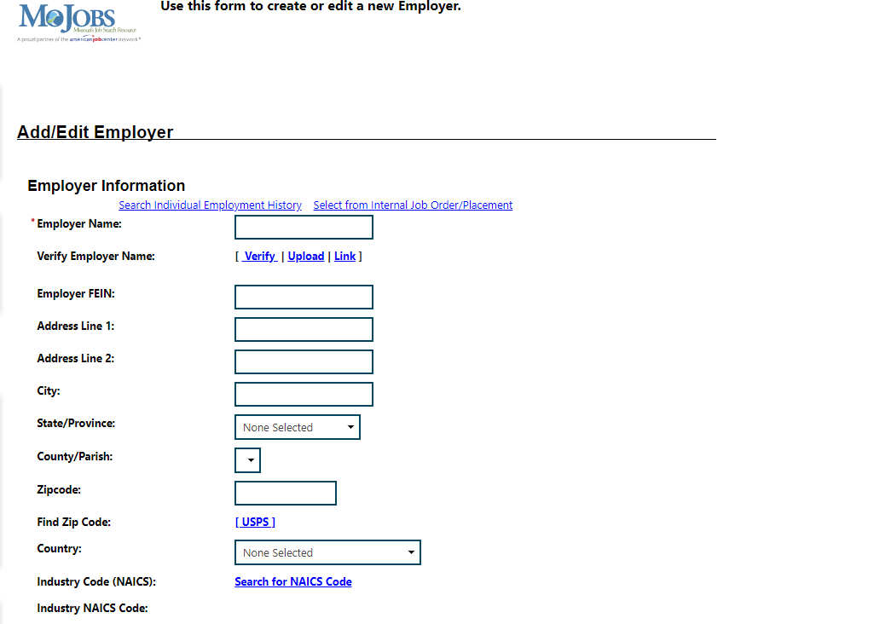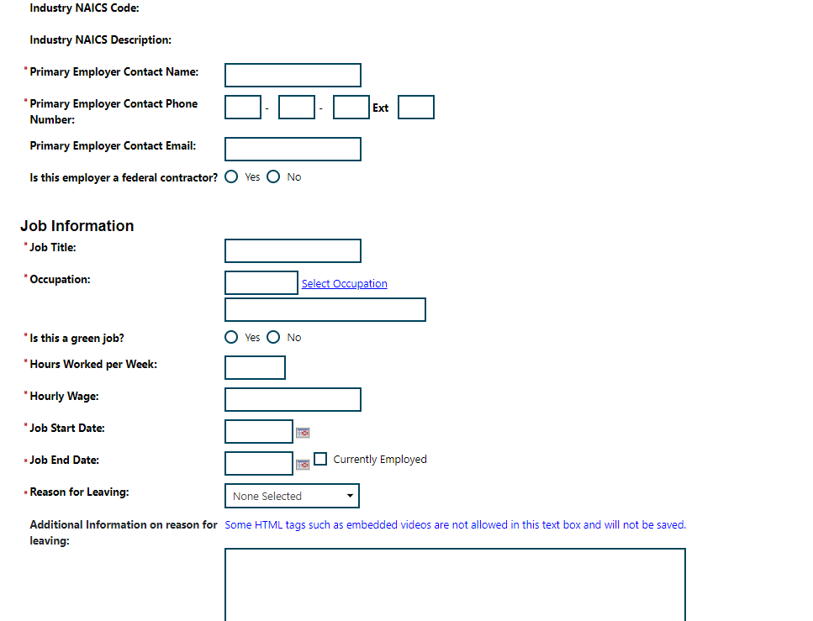
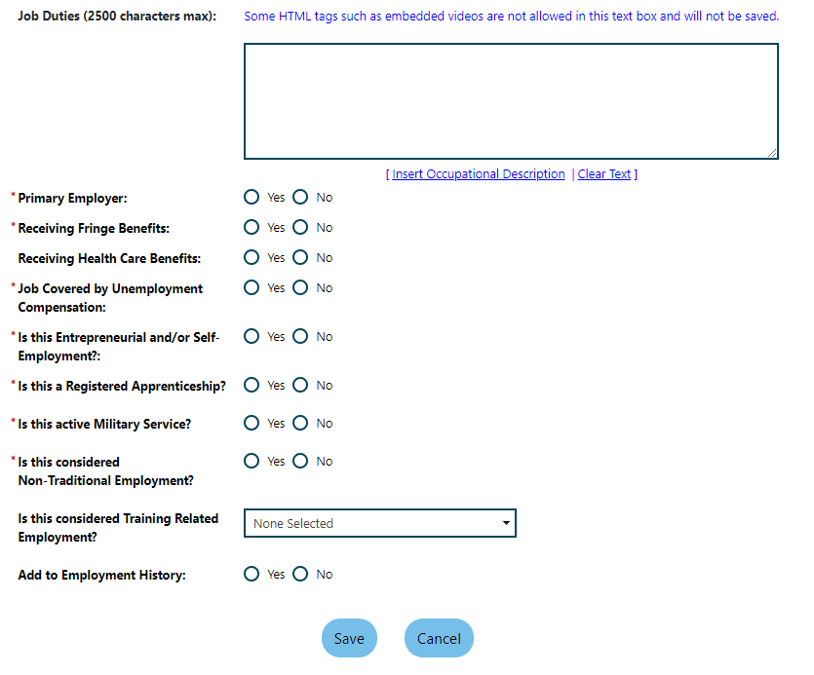

Click Save.

